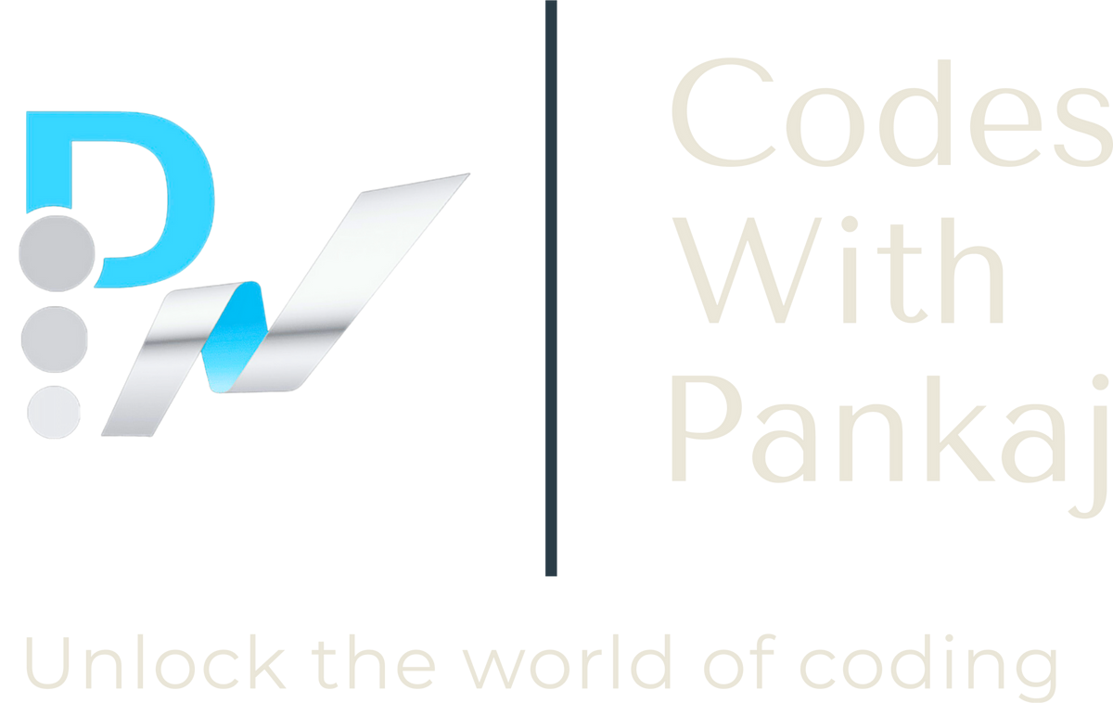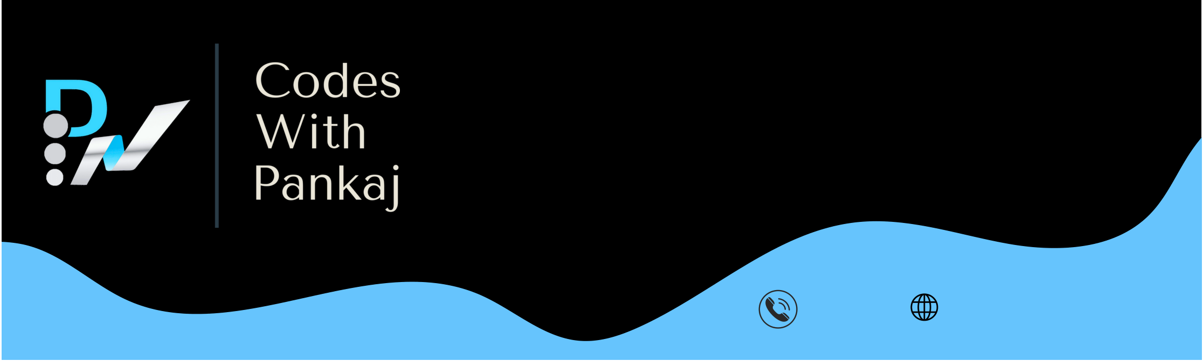

**Complete Python Mastery**

**9252667322**  **www.codeswithpankaj.com**

Everything you need to program in Python in one course

(includes 3 real-world projects)

**Total Hours : 52 Hours**

A complete beginner-friendly course

**No Prior Knowledge Needed**

This course assumes you know nothing about Python or any other programming languages. Go from

complete beginner to expert, with plenty of hands-on exercises along the way.

**What You'll Learn**

Write Python code with confidence

Use Python in machine learning and data science projects

Automate boring, repetitive tasks

Build command-line utilities

Build web scraping tools

Process CSV, JSON, Excel spreadsheets, PDFs, ZIP files, etc

Send emails and text messages

**Module 1: Getting Started ( 1 Hour )**

Introduction to Python

Installing Python

Python Interpreter

Your First Python Program

Python Extension

Running Python Code

Quiz

**Module 2: Primitive Types ( 2 Hours )**

Variables

Strings

Escape Sequences

Formatted Strings

String Methods

Numbers

Working with Numbers

Type Conversion

Quiz

**Module 3: Control Flow (8 Hours)**

Arithmetic Operators

Comparison Operators

Logical Operators

Assignment Operators

Bitwise Operators

Membership Operators

Identity Operators

Operator Precedence

If else

elif

For Loops

Nested Loops

Iterables

While Loops

Exercise

**Module 4: Functions (4 Hours)**

Defining Functions

Arguments

Types of Functions

Keyword Arguments

Default Arguments

*args

**kwargs

Scope

Exercise

**Module 5: Data Structures ( 10 Hours )**

Python Numbers

Python List

Python Tuple

Python String

Python Set

Lambda Functions

Map Function

Filter Function

Zip Function

Stacks

Queues

Tuples

Arrays

Sets

Dictionaries

Exercise

**Module 6: Exceptions ( 1 Hour )**

Exceptions

Handling Exceptions

The With Statement

Raising Exceptions

Cost of Raising Exceptions

**Module 7: Classes ( 14 Hours )**

Classes

Creating Classes

Constructors

Class vs Instance Attributes

Class vs Instance Methods

Magic Methods

Comparing Objects

Making Custom Containers

Private Members

Inheritance

The Object Class

Method Overriding

Multi-level Inheritance

Multiple Inheritance

Abstract Base Classes

Polymorphism

Duck Typing

Extending Built-in Types

Data Classes

**Module 8: Modules ( 2 Hours )**

Creating Modules

Compiled Python Files

Module Search Path

Packages

Sub-packages

Intra-package References

The dir Function

Executing Modules as Scripts

**Module 9: Python Standard Library ( 10 Hours )**

Python Standard Library

Working With Paths

Working with Directories

Working with Files

Working with Zip Files

Working with CSV Files

Working with JSON Files

Working with a SQLite Database

Working with Timestamps

Working with DateTimes

Working with Time Deltas

Generating Random Values

Opening the Browser

Sending Emails

Templates

Command-line Arguments

Running External Programs

NumPy

Pandas

Matplotlib

www.codeswithpankaj.com